Review sheet for IPBES intersessional documentation
see www.ipbes.net/plenary/intersessional for further details
Document name: Background document to support the development of a Conceptual Framework to guide the delivery of IPBES

Reviewer name(s): Sugeng Budiharta, Ya-Ling Chang, Dr Edd Hammill, Elizabeth Law, Maria Martinez-Harms, Dr Anna Renwick, Dr Jessie Wells and Dr Kerrie Wilson

Government/Institution: Australian Research Council Centre of Excellence for Environmental Decisions (CEED: www.ceed.edu.au)

Country: Australia

Email address: k.wilson2@uq.edu.au (Kerrie Wilson)

We appreciate the opportunity to review the background document to support the development of a conceptual framework to guide the delivery of IPBES. We recognise the challenges associated with developing this framework: while biodiversity and ecosystem services are all encompassing, they are poorly defined in theme, space, and time, and are inherently linked to society's institutions and economy. We also acknowledge the importance of a conceptual framework for ensuring uptake and involvement of all key stakeholders of the IPBES. We applaud the expert working group for the recognition of this importance, and the attempt to capture the complexity inherent in the mandate for the IPBES. We also recognise the challenge of developing a conceptual framework that adds value to predecessors and that speaks to the four core functions of the IPBES.
Our review has focused on three themes:
- Treatment of biodiversity: including definitions and relationship with ecosystem services
- Treatment of spatial and temporal scales
- Knowledge generation and decision making: including emphasis on how decisions are made and the importance of scenarios.
We have grouped our comments in relation to these themes, and have attempted to clearly outline suggested actions to redress them. In some cases the three themes are interconnected. In an attempt to clarify our suggestions, we append a revised schematic of the conceptual framework based on our comments. We have outlined in the text accompanying the schematic the connection between our suggested modifications and core functions of the IPBES and also the three themes of our review. We also note several comments at the end of this document that, while significant, do not fall under the three themes that are the focus of our review.
The Australian Research Council Centre of Excellence for Environmental Decisions comprises ~80 researchers and ~150 PhD students, across six national universities and four universities internationally. The Centre has globally recognized capacity and contributions across the three themes that we address. We welcome an opportunity to provide further input on the matters we have raised in this review and on technical documents in the future.
Page number | Line/Paragraph/  Rule number | Comment
7  10  9  7  9 | Lines 22-24, and  Lines 3-5  42-43  21-26  20-27 | Treatment of biodiversity  The intrinsic value of biodiversity is noted on page 7 lines 22-24 and page 10 lines 3-5. Intrinsic values are, however, omitted from the draft schematic. Intrinsic values represent one of the main drivers for people to conserve biodiversity (Mace et al. 2012). We believe that without greater consideration and recognition of belief in intrinsic values in the conceptual framework there will be a risk that a subset of stakeholders will be alienated. This is additionally important as in some cases ecosystem goods and services depend only on a small subset of biodiversity (at least over short timescales) and in some cases are provided by species that are not normally considered in biodiversity conservation, i.e. non-native species (Macfadyen et al. 2012). In these cases focusing purely on those aspects of biodiversity that contribute to the provision of ecosystem goods and services will not lead to better protection for biodiversity overall.  It is important to also refer to the option values of biodiversity, which incorporates the present and future value of healthy ecosystems, and may be found across all scales of biodiversity. For example, the importance of genetic diversity as an insurance against present and future environmental risks. The importance of biodiversity for adaptation is mentioned in page 10 lines 42-43 but not explicitly called option values.  Suggested actions  Refer to option values at around page 7, lines 22-23 and represent both intrinsic and option values in the schematic (see revised schematic below).  There would be value in referring to the distinction made by Mace et al. (2012) between biodiversity as a regulator of ecosystem processes, as a final ecosystem service and as a good itself.  Suggested actions  Suggested modifications to the schematic include clarifying the relationship between biodiversity, ecosystems, and ecosystem functions (using nested boxes as in UKNEA 2012).  Page 8, lines 9- 21 Increased ecosystem functioning will not necessarily result in increased ecosystem service supply, and an increase in some services may trade-off with other services. This potential trade-off may be of particular importance in highly human dominated systems (e.g. dominance of a few species and transformation of ecosystems tends to lead to the decrease of biodiversity and other regulating and cultural services in favour of some provisioning services).  Suggested action  Modify the text under Key Message 6 (page 9-10) to clarify the possibility for trade-offs between ecosystem services to occur.
7  9 | 24  20 | Treatment of biodiversity and links to decision making  “Some ecosystem goods and services are provided directly by biodiversity and ecosystem functioning, such as aesthetics, recreation, regulation of quantity and quality of water resources, or fodder for animals... Other goods and services are produced jointly with "other forms of wealth" including produced, human and financial wealth.” (page 7, line 24)  We disagree with this categorical distinction between services that are solely biodiversity-based and those involving other forms of wealth: all values drawn from biodiversity and ecosystem functioning also involve human actions for the service to reach beneficiaries and are derived in the context of particular management regimes. Critically, these depend on choices (decisions) made by institutions or individuals. For example, national parks may provide aesthetic benefits, but often require substantial financial and human resources to designate and manage. The extent of a good or service’s dependence on ecosystems and humans forms a spectrum, not a categorical distinction.  This text on page 7, line 24 is also inconsistent with the current schematic, since this would imply a directed arrow from Biodiversity to Human Well-being, which doesn't occur. We propose it is better to change the text to speak of this spectrum, and have the full spectrum connected to human wellbeing.  Suggested actions  Re-wording of page 7, 21 – 35 to clarify the spectrum that exists between the extent to which a good or service depends on ecosystems and humans, and incorporate into the schematic (see revised schematic below).  While biodiversity can provide “direct benefits” to people, we highlight that the benefits received are a function of the perspectives and values of stakeholders. Making this distinction clearly will help to separate the intrinsic value of biodiversity and ecosystem functions from the anthropocentric ecosystem service benefits (for example the “sense of place” cultural benefit), especially since the latter will vary over time and space and depending on different human perspectives.  Suggested actions  Page 7 lines 21-35, page 9 line 20 to page 10 line 11  Both of these sections are unclear in their distinction of intrinsic, options, and other more anthropocentric benefits. Clarification through boxed definitions of these values would be beneficial, and would greatly simplify the document. Please also see suggestions below on how to incorporate these concepts into the revised schematic.
14 and 15 | Line 38 (page 14) – Lines 18-36 and 30-41 (page 15) | Treatment of spatial and temporal scales  The document makes reference to issues regarding the spatial and temporal scales of ecosystem services. It also acknowledges the value of being able to scale assessments up and down (page 17, line 16). However, scale issues are not accounted for in the draft schematic. Incorporating issues of scale is crucially important due to the potential trade-offs between immediate and long-term consequences of strategies, and local versus global effects. Because of these trade-offs, consideration of temporal and spatial scales will influence decisions, drivers, strategies and their consequences. It is also critical in respect to the permanence and additionality of strategies and leakage of threats, either spatially or temporally. The importance of accounting for spatial and temporal scales is illustrated by the attention this has received in the literature (e.g. Rodriguez, Beard et al – Ecology and Society 2006, du Tolt, J.T. – Animal Conservation 2010). Considerations of spatial and temporal scales were also integral parts of the Millennium Ecosystem Assessment conceptual framework.  Further integration of the space and time dimensions of biodiversity and ecosystem services is also necessary in order to understand the scope and roles of TEK (traditional ecological knowledge). TEK is necessarily highly contextualized to place.  TEK embodies human and intellectual capital accumulated over many generations, and in many situations may have a vital role in understanding natural variability or changes over longer timescales than scientific observations. At the same time, we should be aware that some aspects of global change may lead to conditions beyond the scope of existing experience or knowledge.  Suggested actions  Please see suggested modifications to the schematic below, which integrate and develop some design elements presented by the MEA (2005).  While scale issues are well addressed in Key Message 11, further integration of the language conceptualising temporal and spatial scales and their linkages within the context of decision making could be made throughout the document.  Clarification of the role of TEK considering these scales as suggested above.
11  13  13  17  15, 16, 18  Schematic | 4-12  1-3  5-8  30 | Knowledge generation and decision making  Suggest emphasising that the constraints of limited resources mean we have to acknowledge the need for choices between interacting outcomes (i.e. synergies, tradeoffs, externalities). Choices can be made based on many different decision processes, and accounting for time.  To emphasise choice will emphasise responsibility and more clearly highlight moral and ethical considerations that underlie our (personal and collective) values.  Suggested actions  Key message 8 and 9 and text within these sections could be modified to highlight the choices that need to be made with limited resources and the possibility for interacting outcomes.  In the current schematic, it appears that human wellbeing directly depends on the productive base of society, and this may be influenced by 'institutions, decisions and drivers'.  Currently, the schematic does not clearly represent strategies to address changes in biodiversity, ecosystem function and ecosystem services. Hence, there is no place within the schematic for alternative scenarios.  Suggested actions  Consider the alternative version of the schematic we have suggested below, where we show that individuals and institutions make decisions (based on the knowledge available) leading to strategies/actions, which may directly influence the drivers of change and/or other forms of capital.  The development of scenarios and characterisation of possible futures is a key element in decision making. While the possibility of using scenarios is identified in Key message 11 (in relation to scale issues, 15: 39 and 16:8) and in Key message 12 (under the Knowledge generation catalysis function 18:3), we feel the conceptual framework must better emphasise the centrality of scenario development given the importance of scenarios for decision making and policy formulation. We must be able to project the consequences of different policy options and management regimes (at global, national and regional scales) on biodiversity otherwise biodiversity will never influence decisions. The same could be said for ecosystem services, although such projections are more common.  Suggested actions  Define “potential futures” and “scenarios” within the text. Indicate in the text that some potential futures are uncertain and some unknown.  Represent in schematic via:  - Include a panel that highlights potential futures, and how these link to strategies, decisions, and actions that underlie drivers of change in the system and are influenced by other elements of the system.  There would be value in, where possible, better integrating the four functions of the IPBES into the schematic for the conceptual framework. Incorporating the assessment function of conceptual framework could be achieved by addressing the comments in relation to spatial scale noted above. The need for prioritising scientific information could be captured. The possibility for adaptation and learning is noted in Key Message 4, and this could also be captured in the schematic also.  Suggested actions  Indicate in the schematic that not all knowledge generated is required to be transferred to institutions/individuals to inform decisions.  Include feedback arrows that indicate that we should learn through the implementation of strategies.

Suggestion to provide simple and transparent definitions:
An overarching comment is that simple and transparent definitions should accompany the conceptual framework (and where possible be summarised and embedded in the schematic) to facilitate communication to a broad set of stakeholders. Examples include definitions of: institutions (especially due to different uses of this term in different fields) and 'intrinsic value'.
Additional comments not captured by the three themes of the CEED review
4 | 21 | Emphasis on multidisciplinary approaches (Key Message 2) should be expanded to recognize multi-stakeholder, multi-scale, and multi-sectorial collaborations. “Multi-disciplinary” is possibly too science focused / academic, and fails to recognize the science-policy-community interface.  The involvement of diverse stakeholders should also be highlighted within the conceptual framework. For example, many environmental decisions are the responsibility of land managers, and key impacts, both positive and negative, can result from the actions of individuals or small community groups, as well as institutions. Consideration of these multiple scales of actions reflects the need for integrated solutions.  Suggested action  Include individuals and institutions in the revised schematic.
5 | 29 | "-recognition of the role that many communities play in managing and maintaining landscape mosaics and biodiversity, where these actions enhance the provisioning of ecosystem services for human wellbeing and/or conserve biodiversity;"  We emphasise that the enhancement of human wellbeing or ecosystem services is not necessarily facilitated by maintaining landscape mosaics, and landscape mosaics may not always result in greater biodiversity.  Suggested action  Modify text on page 5 line 29 to clarify.
7  12 | 27-42  25-27, 29-30 | The link between “other forms of wealth” and ecosystem services requires significant clarification. The term “ecosystem services” reflects the benefits that humans derive from ecosystems. As described, inputs from human wealth might be required to enhance these benefits, but can also be employed for their conservation or management. This latter role of human wealth is not clear.  While we agree that the term “wealth” may be used to describe different forms of utility, we do not believe it differs significantly from the established term “capital” to justify its use. One of the aims of the IPBES document is to be as widely accessible as possible to a range of different users from diverse fields. Inclusion of established and understood terminology encompassing capital may help to achieve this aim.  Forms of capital discussed in the (economic) literature include:  Land (including space and natural resources)  Labour (including volume and skills)  Finance  And, inter alia:  Human capital (knowledge of individuals, including e.g. education and entrepreneurship); Intellectual capital (technological and intellectual property); and Social capital (good will, social acceptance, and social influence).  At the moment, it is not clear how the term wealth is being used in a way that is distinct from the concepts of natural and human capital.  Suggested actions  Suggest using the terminology “ capital” and as discussed in the text above and in justification of the revised schematic, have both natural capital and other forms of capital contributing to a “ goods and services” box.
10 | 14 | While the concept that ES are context specific and dependent on perspectives and values is a central tenet, we are not sure the term “bundles” adds clarity. This term has been used in different ways in the literature, for example to refer specifically to payment of ecosystem service schemes compensating for multiple services provided by one site (note studies suggest this is rarely feasible), or to refer to sets of ecosystem services commonly found together at one site. The latter implies relationships are fixed between services involved – however we often hope that our interventions will either alter or decouple these linkages.  Suggested action  On pg 10 line 14 suggest removing, or else clarifying the term “bundles” to emphasise why it is being used.
10 | 15, 17 | We encourage the use of the phrase “perspectives and values” rather than “preferences”. Preferences can be misguided – for example the displayed preference for junk food. Preferences can also fluctuate, and are not always provide a true representation of the well being we could derive from the options provided to us (for example see research on “synthetic happiness”, e.g. discussed in http://www.ted.com/talks/dan_gilbert_asks_why_are_we_happy.html).  Furthermore, “preferences” implies a fixed, personal opinion. Due to the idea that people have the right to their own opinion this suggests we may have little ability or right to influence preferences. In contrast, use of the terms “perspectives and values” highlights the option of broadening people’s perceptions on ecosystem service and biodiversity issues, and goes to the heart of our moral and ethical values from which our preferences are derived. Preferences are displayed when we have options presented – and here we caution that not in every case will “preferences” displayed though such choices involving a limited set of options actually reflect true desires and values (i.e. what the preference would be, if additional options were included in the choice set).  Suggested action  On page 10 (lines 15 and 17) replace the term “preferences” with “perspectives and values”.

Description and explanation of revised IPBES conceptual framework schematic: ARC Centre of Excellence for Environmental Decisions (CEED), Australia.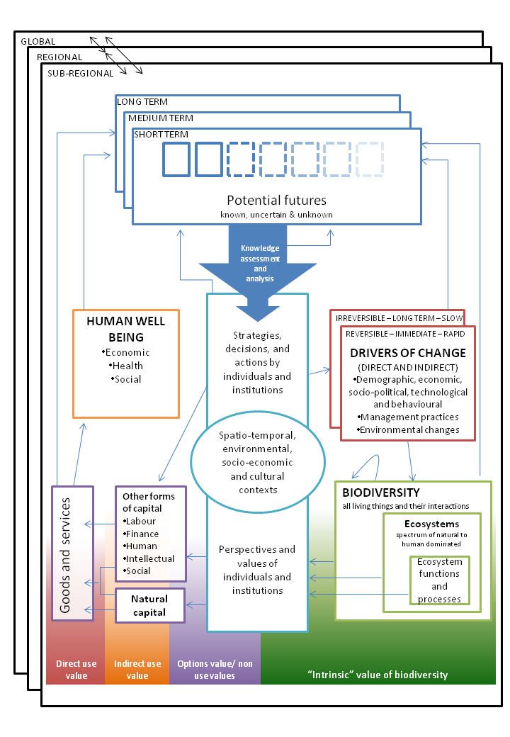
We have developed a revised conceptual diagram which may serve as a starting point for further discussion. This diagram has been developed though integrating the key contributions of the IPBES with previous ecosystem service assessment conceptual frameworks, particularly the UKNEA (2012) and the MEA (2005). We feel this integrates the four core functions of IPBES, as well as highlighting key comments from the CEED review as detailed below.
- IPBES core function 1: identification and prioritisation of key information needs for policymakers;
- IPBES core function 2: assessments of knowledge for biodiversity and ecosystem services;
- IPBES core function 3: supporting policy formation and implementation;
- IPBES core function 4: prioritising the key capacity building needs to improve science-policy interface.
- CEED theme 1: treatment of biodiversity, including definitions and relationship with ecosystem services.
- CEED theme 2: treatment of temporal and spatial scales
- CEED theme 3: knowledge generation and decision making, including emphasis on how decisions are made and the importance of scenarios.
The text below provides a detailed explanation of the proposed modifications to the schematic, and indicates which IPBES core functions and CEED themes are addressed by element suggested. The reference numbers refer to indicators on the figure located below.

Reference # |  |  | Core function/CEED theme
Reference # | Framework element description and justification |  | IPBES 1 | IPBES 2 | IPBES 3 | IPBES 4 | CEED 1 | CEED 2 | CEED 3
1 | A panel has been included highlighting potential futures (scenarios), and how these link to strategies, decisions, and actions that underlie drivers of change in the system.
2 | Potential futures are a set of known (defined and certain), uncertain (defined but uncertain), and also unknown (unimagined) scenarios of the future. These exist over short, medium and long term planning horizons. They are influenced directly by all elements of the figure: drivers of change, biodiversity, goods and services produced, the status of human well being, and the strategies, decisions and actions taken by both institutions and individuals.
3 | To make decisions we imagine potential futures, compile information on expected outcomes, and use this to determine what we believe to be the best course of action (policy, strategy). That there are unknown potential futures highlights that even decisions made with the best information is unlikely to be optimal in all possible outcomes.
4 | That not all information is needed or used by decision makers is shown through a large arrow of knowledge assessment and analysis leading to a smaller arrow entering into the “Strategies, decisions and actions” box. This highlights the need for prioritization of knowledge generation.
5 | To highlight the role played by both institutions and individuals we have included both in the same diagram. Institutions are fundamental actors particularly at larger scales, but often rely on the actions of individual land managers to effect policies. Individual actors are therefore a critical component of the IPBES framework.
6 | Strategies, decisions, and actions by individuals and institutions influence both the drivers of change and other forms of capital. We highlight that these are placed within specific spatio-temporal, environmental, socio-economic, and cultural context. This is important in order to characterise the multi-stakeholder, multi-disciplinary nature of many environmental decisions, and can also incorporate indigenous and local knowledge systems, as endorsed by the IPBES in Key messages 2 and 3.
7 | We highlight several key considerations of temporal scale in the context of drivers of change: that drivers can be slow, or rapidly acting; that they can occur immediately or in the more distant future; and that they can be reversible, or irreversible.
8 | Biodiversity is defined within the diagram as underlying ecosystem functions and processes and the relationship between these components is clarified: ecosystems are a sub-component of biodiversity (and can be natural or human dominated), and ecosystem functions and processes are a particular sub-component of ecosystems. This nested image is modified from the UKNEA (2012) conceptual framework.  Arrows from each of the nested levels of biodiversity through the “perspectives and values” box suggest that each of these levels can contribute to natural capital and human well being.  We highlight that biodiversity is influenced by both drivers of change, and by its own particular biological history. We envisage this as capturing the idea of resilience and feedbacks found in natural systems, and represent it as an arrow from biodiversity to itself.
9 | We draw on the definition of ecosystem services as “the benefits people derive from nature” (MEA 2005) by highlighting that natural capital is drawn from ecosystem functions and processes, but these benefits are derived through humans having particular perspectives and values determined by context. We note these contexts also impact on value of other forms of capital.
10 | Goods and services range along a spectrum of predominantly naturally produced, to predominantly produced by other forms of capital. We put all goods and services within a single box to highlight both this spectrum, and that goods and services from both ends of the spectrum may substitute for each other.  We use standard terms for forms of capital developed extensively in the economic literature.
11 | We include the relationships of different types of “value” along the transformation of biodiversity to goods and services.  We show “intrinsic” value of biodiversity as mainly centred on the biodiversity side, to reflect that the term “intrinsic value” is aiming to reflect the value of biodiversity for its own sake. However, we also acknowledge that the importance of this value is dependent on human perspectives and values. Options and non use values, indirect use value, and direct use value, are then progressively illustrated as incorporating increasing levels of capital input.
12, 6 | Similar to the MEA (2005), we encompass the whole figure in scale context boxes of sub-regional, regional, and global. We also show these interact with each other using arrows. Consideration of scale is a key influence in the central portion of the schematic illustrating context.

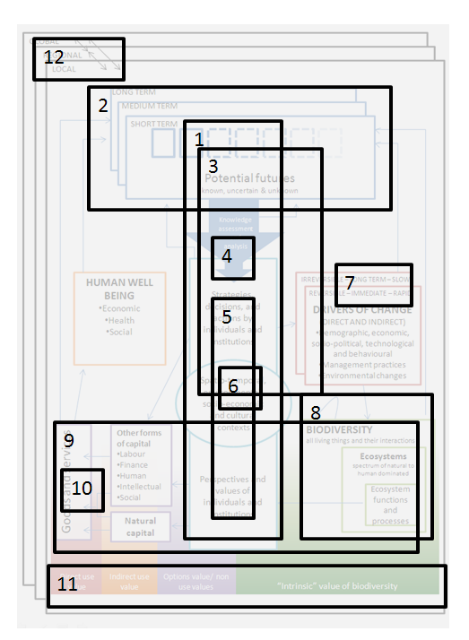
Figure showing reference numbers for each comment above and approximate location in the revised schematic.

